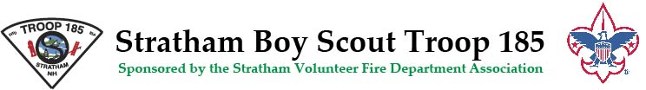
WINTER CABIN CAMPING, MARCH 8-10, 2019
PACKING LIST
- Snow equipment such as sleds, tubes, footballs, frisbees, etc.
- Other activities such as books, games, cards, etc.
- Scout Handbooks as we will be working on advancement.
- Mess Kit
- Sleeping Bag, Pillow, Toothbrush
- Outdoor Clothing - Lots of warm clothing, boots, snow pants, hats, gloves, etc.

Patrol Leaders will be buying and bringing food. The address is: Hidden Valley Scout Camp, 2 Eileen Shore Rd, Gilmanton Iron Works, NH 03837
Departure from Stratham Fire Station at 4:45 pm on Friday. Departure time from Hidden Valley on Sunday will be 9:30-10:00 am. We all depart at the same time in order to make clean up fair, so there are no early departures on Sunday.

